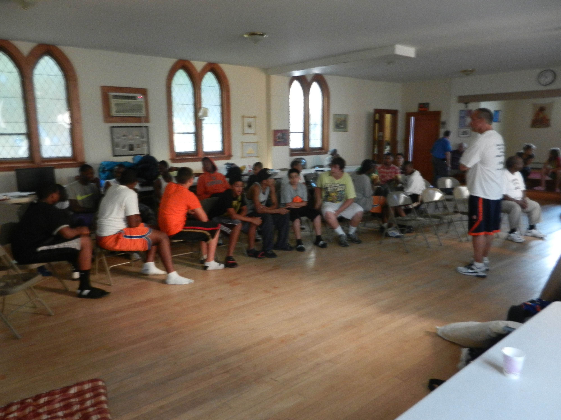
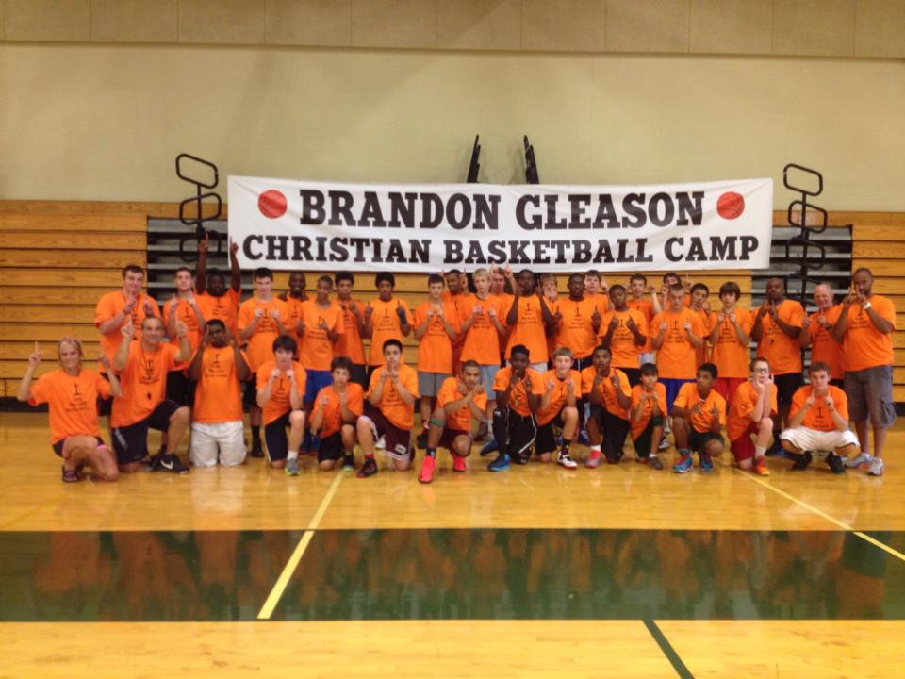
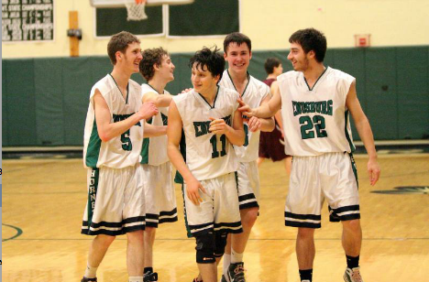
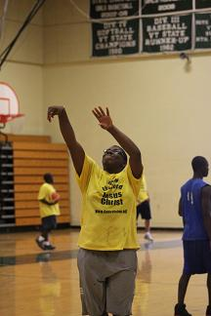
Brandon Gleason

Christian Boys Basketball Camp 2015

Ages: 13-18 Cost: $100 Camp Week: August 10-14, 2015, Enosburg, Vermont. 8:30am-3pm.

Thanks be to God, who gives us the VICTORY through our Lord Jesus Christ. 1 Corinthians 15:57

Come and be a part of a great basketball camp. You will be able to develop your skills while learning from great coaches, and also be able to apply it while playing throughout the day. There will be a Christian message given during of each camp day.

Camp is dedicated Brandon Gleason, a student and basketball player at Enosburg High School who died tragically on April 27, 2013. Brandon would have graduated June 2013, and was the Player of the Year in the Mountain League, and one of the best players in the state of Vermont. Brandon was a person who exhibited all the traits of a champion on and off court, and showed great love to everyone.

For overnight campers, 50$ nonrefundable deposit must be received by August 3, 2015.
Camp sold out last year.
Registration Form

(This form may be duplicated. Health Form will need to be completed as well)

CONTACT INFORMATION

Camper Name (first) _____________________________ (last) __________________________

Camper E-mail _____________________________________ Birth date_______________

Age________ Grade Entering ________

Street Address __________________________________________

City____________________ State__________ Zip____________
Where we will send correspondence

Parent/Guardian Name (first) _____________________________ (last)___________________

Parent/Guardian E-mail __________________________________ Phone __________________

How Did You Hear About the camp? ______________________________________

Fee included with registration: $______
Make checks payable to “God’s Vision Ministry, Inc.”
All questions should go to Matt Luneau at (315) 952-5005.

Please complete and mail the registration form and payment to:
God's Vision Ministry
c/o Matt Luneau
PO Box 812
Enosburg, VT 05450

www.Godsvision.net

