Run / Walk for Jesus
Saturday, June 29
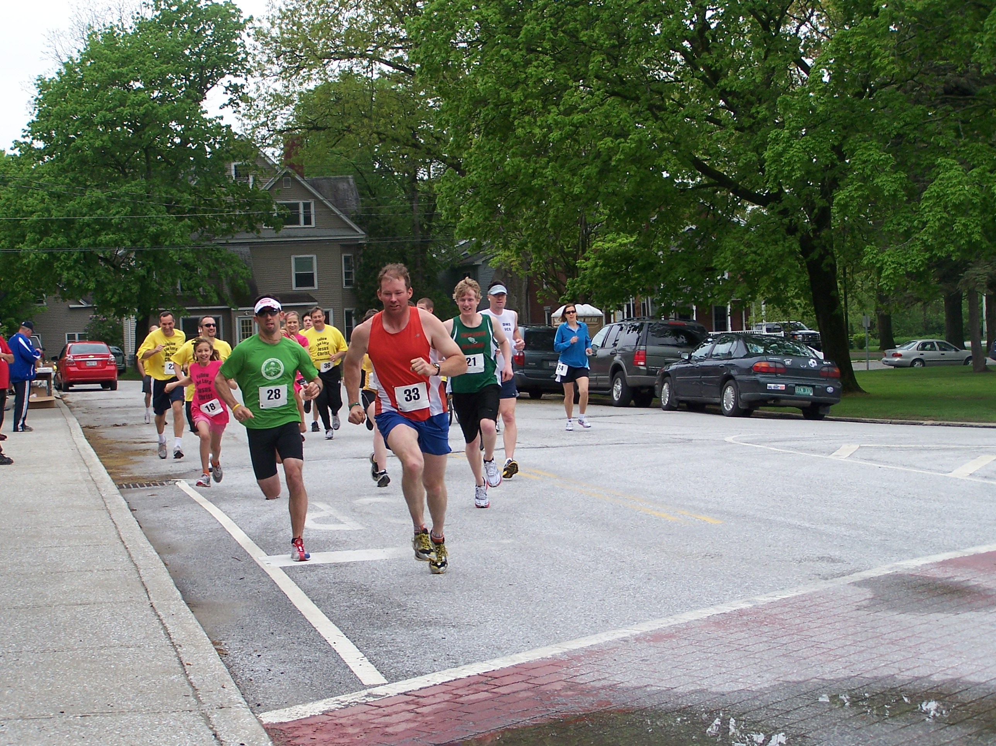
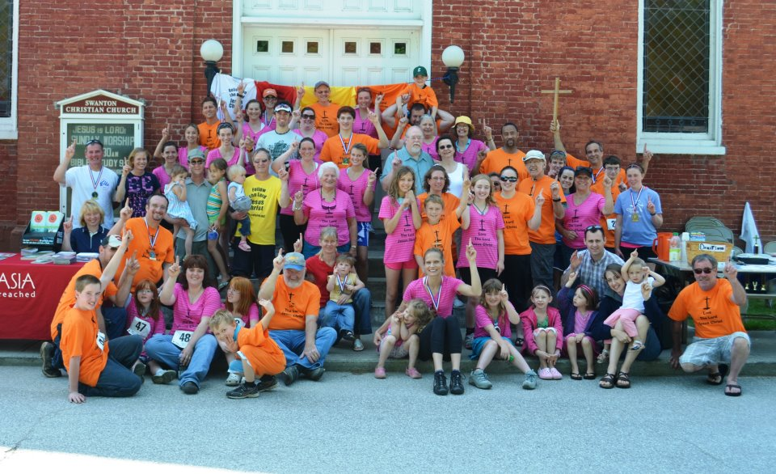
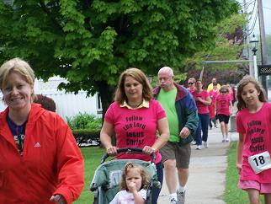

Time: 10:00 am

Start/Finish: Swanton Village Green

Run/Walk: 5K Run or 2 mile walk

Registrations: online at www.GodsVision.net

Race Fee: $15 in mail, $20 the day of the race. Family discount: Family of 3 pay $40, then $10 for each additional family member. Groups of 10 or more will be $10 a shirt. Discounts only apply for early mail-in registrations. Early registration forms need to be mailed by June 22, 2019 to address on the registration form. Race day registration starts at 8:30am and ends at 9:30am at Swanton Village Green.

Awards: Age group awards for male and female winners

More info: 802-363-5566 or bruecknerjohn@gmail.com or www.GodsVision.net

RUN / WALK FOR JESUS - 5K RUN & 2 MILE WALK

Date & Time: Saturday, June 29, 2019 at 10:00 AM. Race day registration starts at 8:30am and ends at
9:30am.

Place: Swanton Village Green

Course: Rt. 7

Awards: Awards to the overall male and female and top 3 finishers in each age group.

Age Groups: Male Female
6 & Under 6 & Under
7-9 7-9
10-13 10-13
14-19 14-19
20-29 20-29
30-39 30-39
40-49 40-49
50-59 50-59
60-69 60-69
70+ 70+
Race Fee: $15 in mail, $20 the day of the race. Family discount: Family of 3 pay $40, then $10 for each additional family member. Groups of 10 or more will be $10 a shirt. Discounts only apply for early mail-in registrations. Early registration forms need to be mailed by June 22, 2018 to address below. Race day registration starts at 8:30am and ends at 9:30am at Swanton Village Green.
Race day registration and bib pickup will take place at Swanton Village Green from 8:30am – 9:30am.
Questions: Call John at 802-363-5566 or e-mail: bruecknerjohn@gmail.com
------------------------------------------------------------------------------------------------------------------------------------
RUN / WALK FOR JESUS - 5K RUN & 2 MILE WALK Entry Form

Name___________________________________Age on race day________ Sex (M/F)_____
(Please print)
Address______________________City/Town________________State______ Zip________

E-mail Address____________________________Telephone__________________________

T-Shirt Size ( ) Small ( ) Medium ( ) Large ( ) X Large ( ) XXL

Waiver: Waiver must be signed by all entrants or by a parent/guardian if under the age of 18.

I know that running a road race is a potentially hazardous activity. I should not enter and run unless I am
medically fit and properly trained. I agree to abide by any direction of a race official relative to my ability
to safely complete the race. I assume all risks associated with participating in this event. I release and hold
harmless the RUN/WALK FOR JESUS 5K, its sponsors, its volunteers, the RUN/WALK FOR JESUS 5K
committee, its sponsors, its volunteers, their representatives and successors and Swanton Village, Inc. from
all claims and liabilities of any kind arising out of my participation in this event even though that liability
may arise out of negligence or carelessness of any kind of the persons named in this waiver.
I certify by signing below that I have read the above waiver and agree to its terms and conditions.

Signed____________________________________________Parent or Guardian signature if under 18.

Checks should be made out payable to “God’s Vision Ministry”
Mail entry form & check to:
Race Administrator, 8 Farrar St., Swanton, VT 05488

