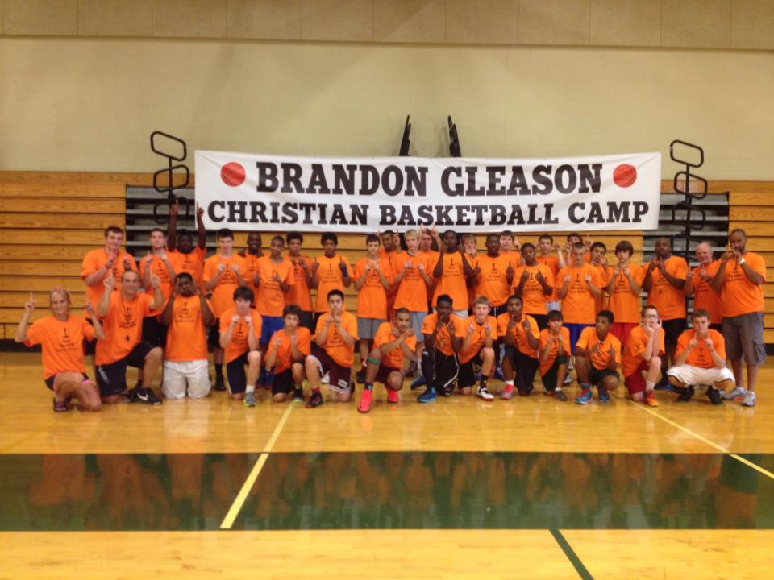
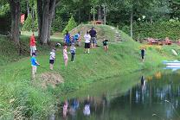
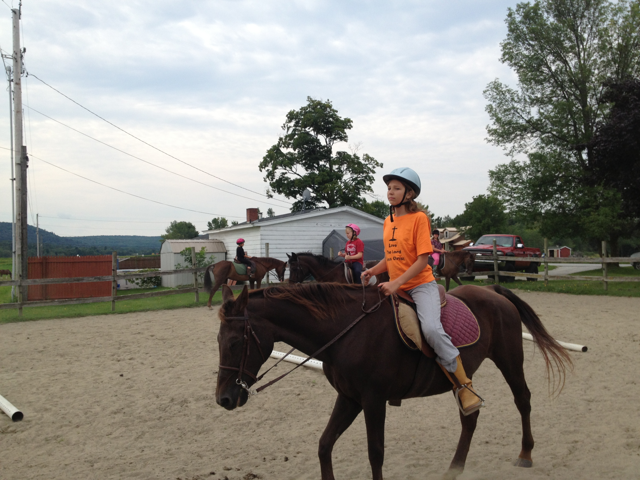
Summer Camps 2014

Limited space for all the camps

Basketball Camps
Come and be a part of a great basketball camps. Held at Enosburg High School. Directed by Matt and Ilze Luneau- www.BasketballFamily.com. They will be teaching youngsters the skills that it takes to be a successful basketball player. Youngsters will be learning skills, and have time to apply those skills in game situations. Guest speakers.

Boys Basketball Camps
June 23-27
9:00am-11:00am Ages 8-11
11:30am-1:30pm Ages 12 and up
Cost: $40

July 7-11
9:00am-11:00am Ages 8-11
11:30am-1:30pm Ages 12 and up
Cost: $40

Coed Basketball Camp
August 11- August 15
9am- 11:00am Ages 9-15
Cost: $40

Brandon Gleason Christian BOYS Basketball Camp
August 4-8, 8:30am- 4pm, Ages 13-18
Cost: $75 day camp; $100 overnight

Summer Day Camp- July 28-August 1, 9am-3pm, Ages 9-15, Coed. Cost:$100
Held at God's Vision Retreat, 141 Sweet Hollow Road, Sheldon, VT. Directed by Matt and Ilze Luneau.
Fishing, swimming, bike trail, field for games!

Horse Riding Camp- July 14- 18, 9am-12pm, Ages 9-14. Cost: $50
Sponsored by and held at Phoenix Meadows Horse Farm on Rt. 105 in Swanton. Christian messages will be given at the beginning of the Horse Riding lessons. The Camp will not only teach how to ride the horses, but also teach how to put on and take off the horse tack, and how to feed the horses as well.

For any questions on these camps please visit www.BasketballFamil.com or www.Godsvision.net to download the registration form, make check payable to “God's Vision Ministry” and mail it to PO Box 812, Enosburg, VT 05450. Call Matt Luneau at (315) 952 5005 or (802) 933-3052 with any questions. “It All Starts with God’s Vision!”

God’s Vision Camp Registration Form
315-952-5005 or 802-933-3052
www.GodsVision.net
(This form may be duplicated)

CONTACT INFORMATION

Camper Name (first) _____________________________ (last) __________________________

Gender male female

Camper E-mail _____________________________________ Birth date_______________

Age________ Grade Entering ________

Street Address __________________________________________

City____________________ State__________ Zip____________
Where we will send correspondence

Parent/Guardian Name 1 (first) _____________________________ (last)___________________

Parent/Guardian E-mail __________________________________ Phone __________________

Parent/Guardian Name 2 (first) _____________________________ (last) __________________

Parent/Guardian E-mail __________________________________ Phone __________________

How Did You Hear About the Camps? ______________________________________

CAMP CHOICE (check which camp(s) you plan to attend)

Basketball Camp (list dates) _________________________________________

Summer Day Camp________

Horse Riding Camp________

TOTAL FEE: $________

TOTAL included with registration: $________

Make checks payable to “God’s Vision Ministry, Inc.”

Please complete and mail the registration form and payment to:
God's Vision Ministry, Inc.
PO Box 812
Enosburg, VT 05450

